**File Management API Sample Documentation**

**Steps:**

1. Create a “test” folder in ‘C’ Drive

“C:\test”

1. Create below folder structure under “test” folder with same file extension:

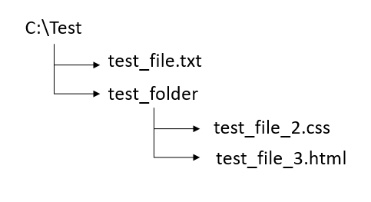

1. To create virtual directory in TcHMI project, Server should be configured as:
2. Click on “Server” option in explorer window & expand it
3. Then double click on “TcHmiSrv”

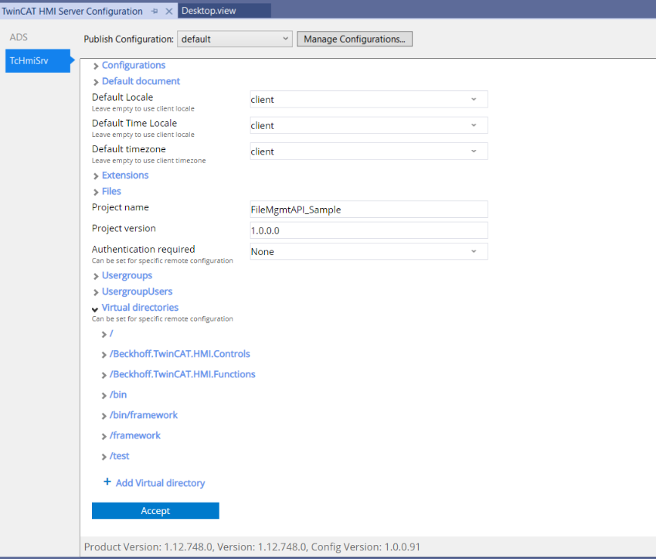

1. Expand virtual directories option & click on “Add Virtual directory”

Virtual directory is given as:

Name: /test

Virtual directory: C:\test\

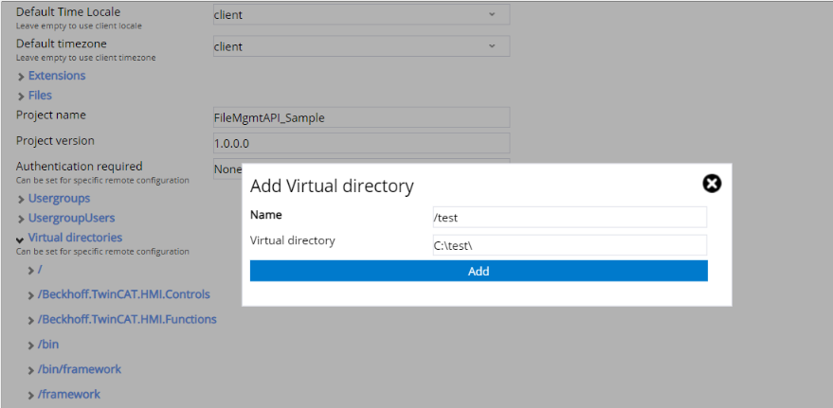

1. Click on Add & Accept to save all changes.
2. In FileManagementAPI Sample project:

Desktop.view contains following buttons:

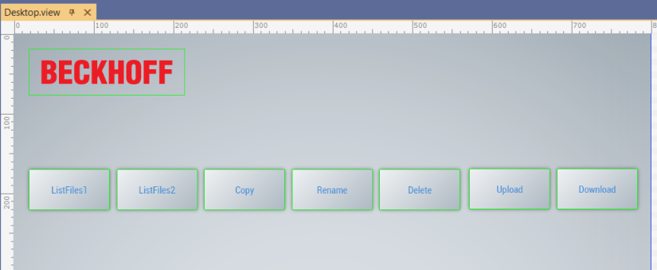

1. On pressed ListFiles1 & ListFiles2 button, it will list files in browser’s console:

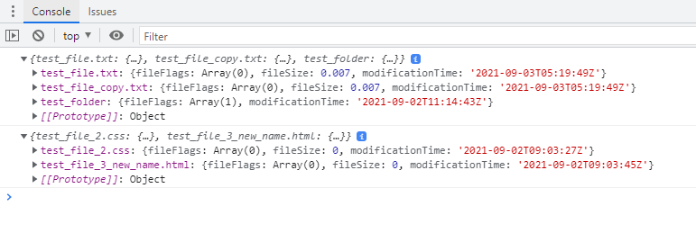

1. On Clicked Copy button, the result is:

Before click:

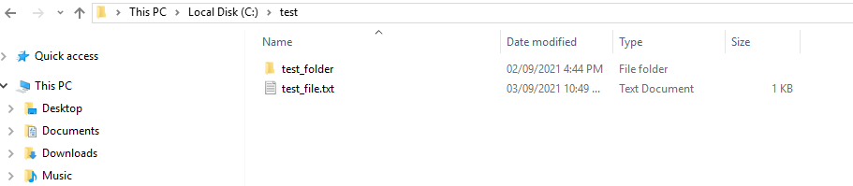

After click:

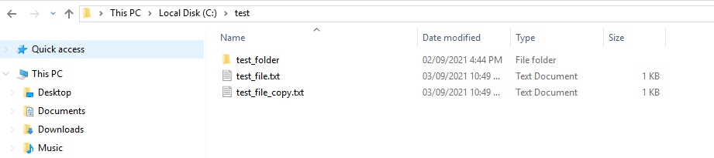

1. On Clicked Rename button:

File get renamed with new name

Before:

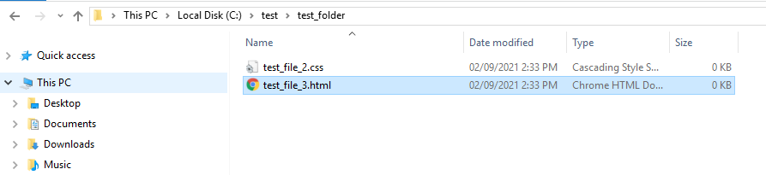

After:

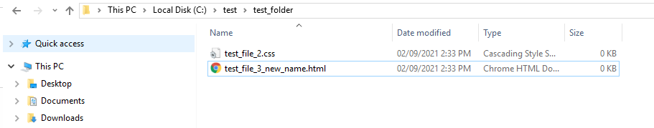

1. On Clicked Delete button:

File get deleted from directory path.

Before:



After:

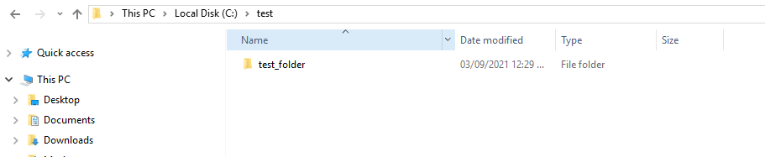

1. On clicked Upload button, it will pop up a window to select single or multiple files.

For example: Here “debug.log” is selected.

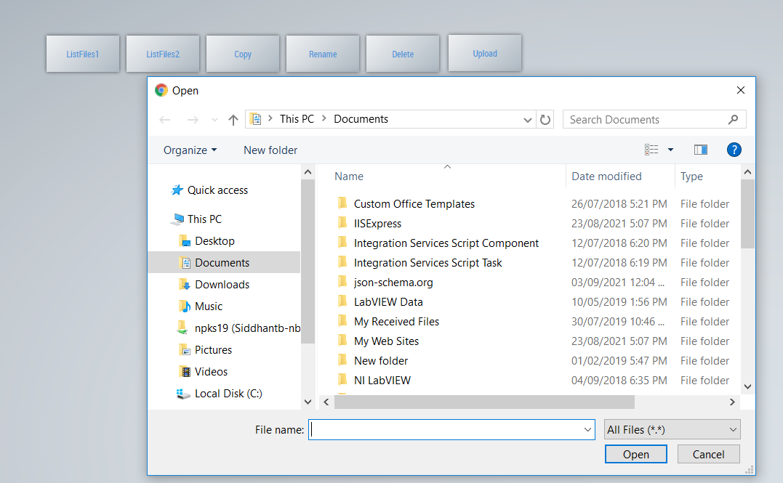

After that select file which is to be uploaded to the destination path.

Before:

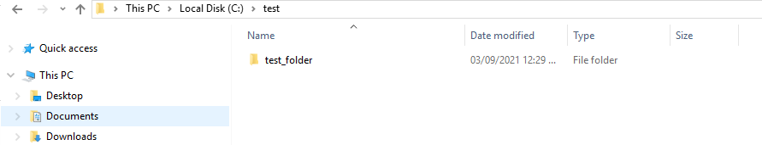

After: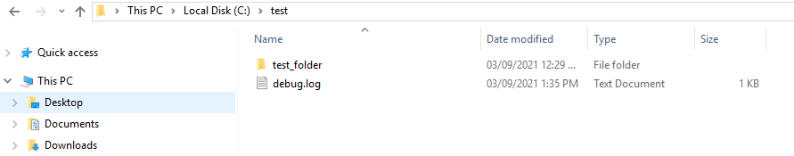

1. On Clicked Download button:

File will be downloaded to default download location of the browser.